**RAJALAKSHMI ENGINEERING COLLEGE**

**RAJALAKSHMI NAGAR, THANDALAM – 602 105**





|  |
| --- |
| **CS23332**  **DATABASE MANAGEMENT SYSTEM LAB** |
| **Laboratory Observation Note Book** |

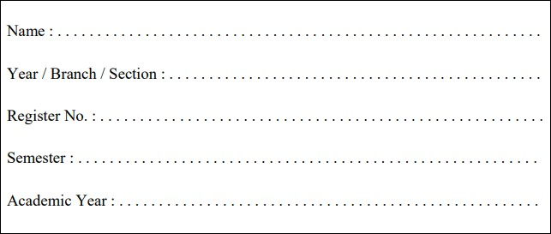

Anto Ashik U H

2

nd

Year/ AIML / A

2315010

16

3

rd

Semester

2024

-

2025

**CS23332 DATABASE MANAGEMENT SYSTEMS**

|  |  |
| --- | --- |
| Name | Aniketh J |
| Roll No | 231501014 |
| DEPT | AIML |
| SEC | A |

**INDEX PAGE**

|  |  |  |  |  |  |  |  |  |  |
| --- | --- | --- | --- | --- | --- | --- | --- | --- | --- |
| **SL.NO** | | **DATE** | | **NAME OF THE EXPERIMENT** | | **PAGE NO** | **MARK** | **FACULTY SIGNATURE** | |
| **01** | | 24-7-2024 | | CREATION OF BASE  TABLEAND DML  OPERATIONS | |  |  |  | |
| **02** | | 26-07-2024 | | DATA MANIPULATIONS | |  |  |  | |
| **03** | | 30-07-2024 | | WRITING BASIC SQL SELECTSTATEMENT | |  |  |  | |
| **04** | | 02-08-2024 | | WORKING  WITH  CONSTRAINTS | |  |  |  | |
| **05** | | 07-08-2024 | | CREATING VIEWS | |  |  |  | |
| **06** | | 14-08-2024 | | RESTRICTING AND SORTINGDATA | |  |  |  | |
| **07** | | 27-08-2024 | | USING SET OPERATORS | |  |  |  | |
| **08** | | 03-09-2024 | | WORKING WITH MULTIPLETABLES | |  |  |  | |
| **09** | | 10-09-2024 | | SUB QUERIES | |  |  |  | |
| **10** | | 20-09-2024 | | AGGREGATING  DATAUSING  GROUP FUNCTIONS | |  |  |  | |
| **11** | | 24-09-2024 | | PL SQL PROGRAMS | |  |  |  | |
| **12** | | 01-10-2024 | | WORKING WITH  CURSORPROCEDURES  AND FUNCTIONS | |  |  |  | |
| **13** | | 08-10-2024 | | WORKING WITH TRIGGER | |  |  |  | |
| **14** | | 18-10-2024 | | MONGO DB | |  |  |  | |
| **15** | | 25-10-2024 | | OTHER DATABASE OBJECTS | |  |  |  | |
| **16** | | 1-11-2024 | | CONTROLLING USER ACCESS | |  |  |  | |
| **Ex.No.: 1** | | | | **CREATION OF BASE TABLE AND DML OPERATIONS** | | | |
| **Date:** | | 24/7/24 | |

1. Create MY_EMPLOYEE table with the following structure

|  |  |  |
| --- | --- | --- |
| NAME | NULL? | TYPE |
| ID | Not null | Number(4) |
| Last_name |  | Varchar(25) |
| First_name |  | Varchar(25) |
| Userid |  | Varchar(25) |
| Salary |  | Number(9,2) |

CREATE TABLE MY_EMPLOYEE (ID NUMBER(4) NOT NULL, Last_name

VARCHAR2(25), First_name VARCHAR2(25), Userid VARCHAR2(25),Salary NUMBER(9,

2));

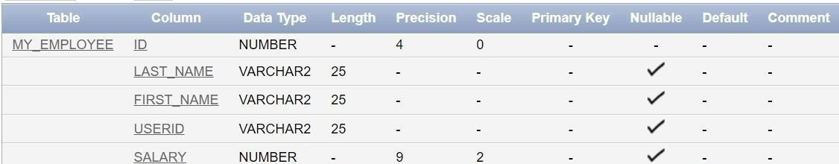

1. Add the first and second rows data to MY_EMPLOYEE table from the following sample data.

|  |  |  |  |  |
| --- | --- | --- | --- | --- |
| **ID** | **Last_name** | **First_name** | **Userid** | **salary** |
| 1 | Patel | Ralph | rpatel | 895 |
| 2 | Dancs | Betty | bdancs | 860 |
| 3 | Biri | Ben | bbiri | 1100 |
| 4 | Newman | Chad | Cnewman | 750 |
| 5 | Ropebur | Audrey | aropebur | 1550 |

Begin

INSERT INTO MY_EMPLOYEE VALUES (1, 'Patel', 'Ralph', 'rpatel', 895);

INSERT INTO MY_EMPLOYEE VALUES (2, 'Dancs', 'Betty', 'bdancs', 860); End;

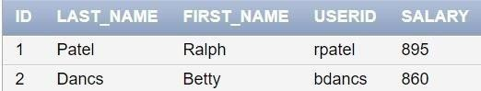

1. Display the table with values.

Select * from My_Employee;



1. Populate the next two rows of data from the sample data. Concatenate the first letter of the first_name with the first seven characters of the last_name to produce Userid.

Begin

INSERT INTO MY_EMPLOYEE (ID, Last_name, First_name, Userid, Salary)

VALUES (3, 'Biri', 'Ben', SUBSTR('Biri', 1, 1) || SUBSTR('Biri', 1, 7), 1100);

INSERT INTO MY_EMPLOYEE (ID, Last_name, First_name, Userid, Salary)

VALUES (4, 'Newman', 'Chad', SUBSTR('Newman', 1, 1) || SUBSTR('Newman', 1, 7), 750); End;

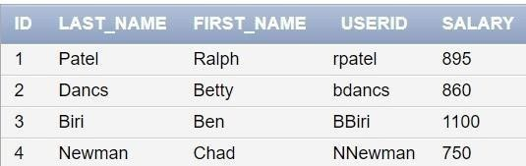

1. Delete Betty dancs from MY _EMPLOYEE table.

DELETE FROM MY_EMPLOYEE WHERE Last_name = 'Dancs';

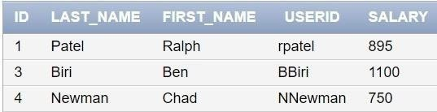

1. Empty the fourth row of the emp table.

DELETE FROM MY_EMPLOYEE WHERE ID = 4;

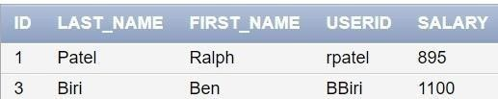

1. Make the data additions permanent.

COMMIT;

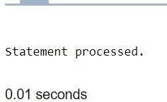

1. Change the last name of employee 3 to Drexler.

UPDATE MY_EMPLOYEE SET Last_name = 'Drexler' WHERE ID = 3;

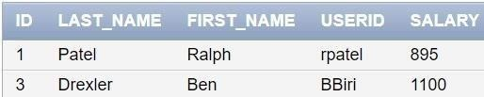

1. Change the salary to 1000 for all the employees with a salary less than 900.

UPDATE MY_EMPLOYEE SET Salary = 1000 WHERE Salary < 900;

